**Sky130 Day-1 to 5**

**Inception of open-source EDA, OpenLANE and Sky130 PDK**

**Brief Introduction:-**

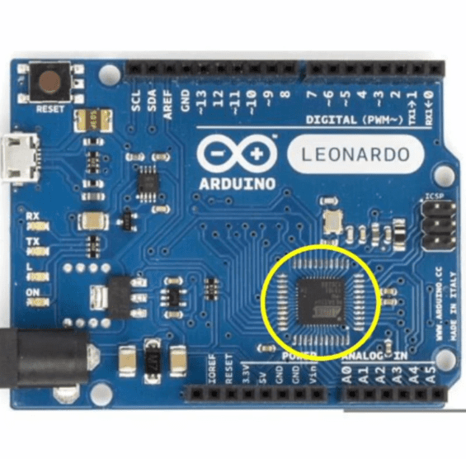

(Image credits:- VSDIAT)

This is an Arduino Board which is a type of “Leonardo”. We are mentioning this to you because we will work on a similar project. The industry lying inside the encircled area is the “Chip”. Our main focus is to develop a Chip in this Advanced Physical Designing Program (level-3).

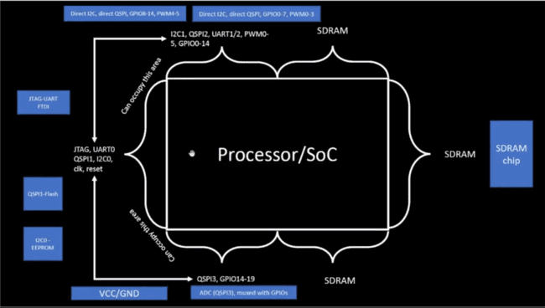

(Image credits:- VSDIAT)

A Block diagram of a processor.

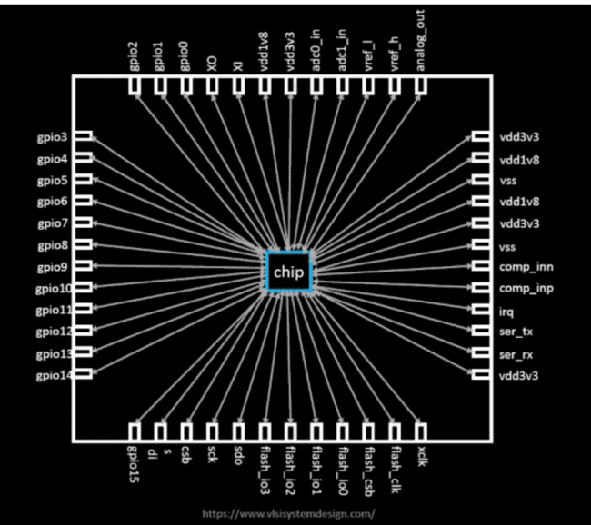

(Image credits:- VSDIAT)

Chip inside the Package known as “QFN-48” with connected to pins through wire bonds.

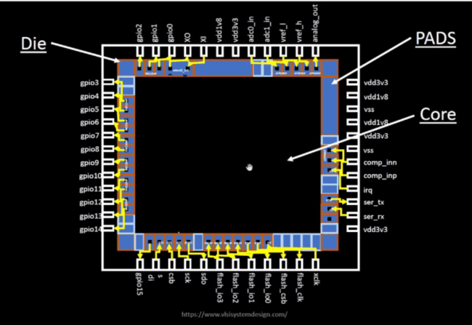

(Image credits:- VSDIAT)

Structure and components of a Chip. “Pads” are like doors of the Chip which allows or disallows signals to go inside or outside the Chip. “Core” is the main part of the Chip where all the logic gates and instructions are kept. Processing is done in the Core. “Die” is the Area or Boundary of the Chip. Basically, Die is the group of Pads and thus form an Area.

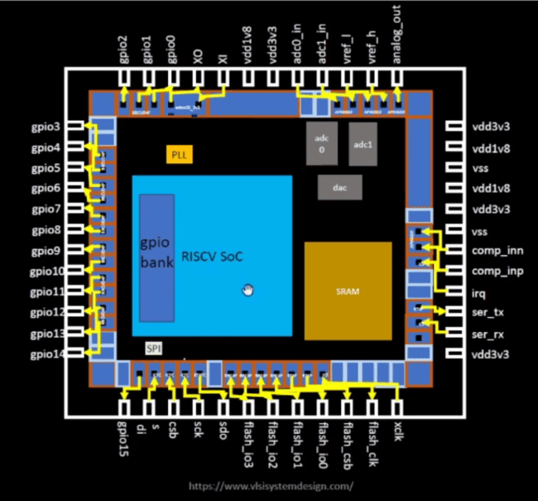

(Image credits:- VSDIAT)

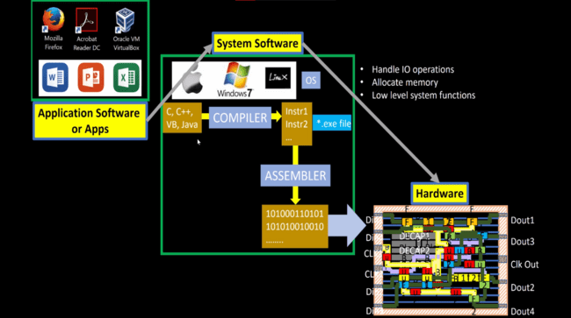

(Image credits:- VSDIAT)

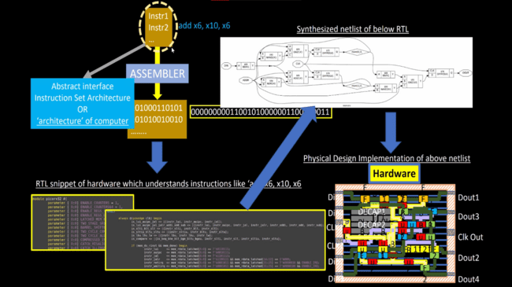

(Image credits:- VSDIAT)

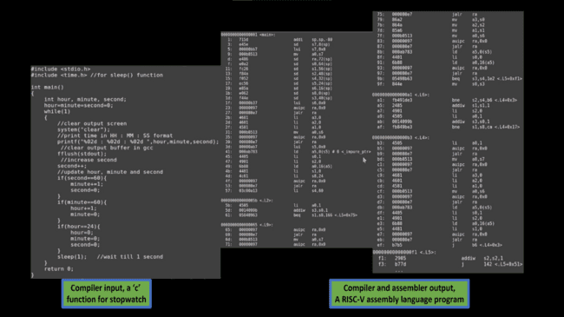

(Image credits:- VSDIAT)

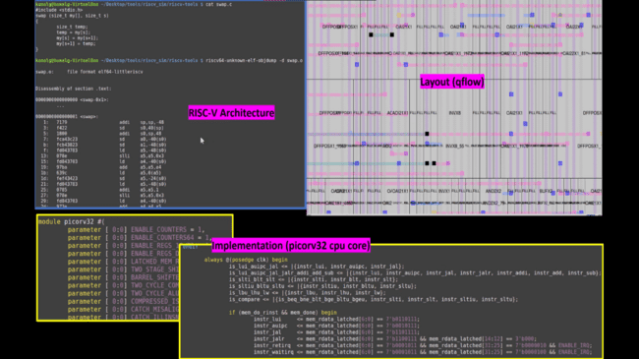

(Image credits:- VSDIAT)

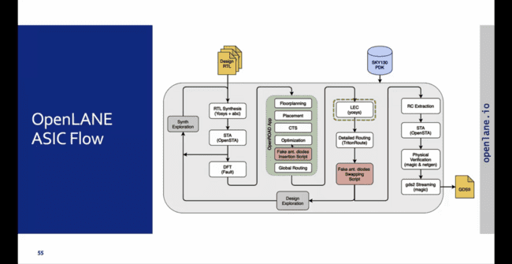

(Image credits:- VSDIAT)

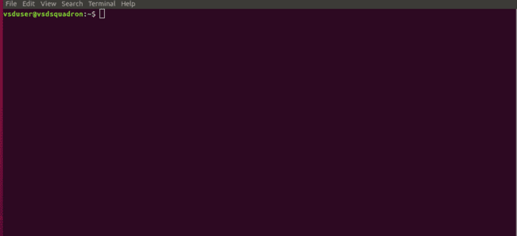

(Image credits:- AUTHOR)

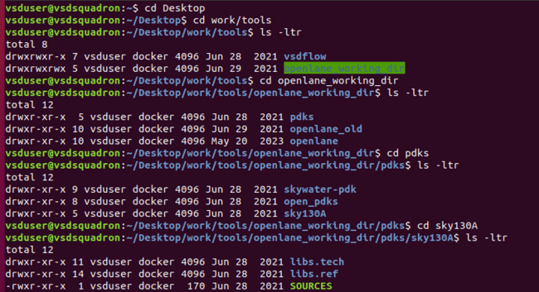

(Image credits:- AUTHOR)

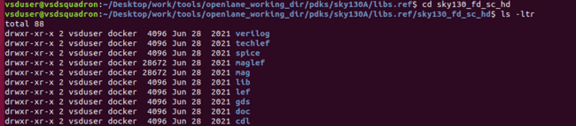

(Image credits:- AUTHOR)

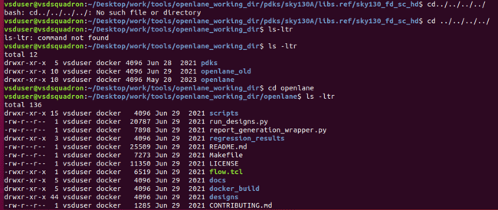

(Image credits:- AUTHOR)

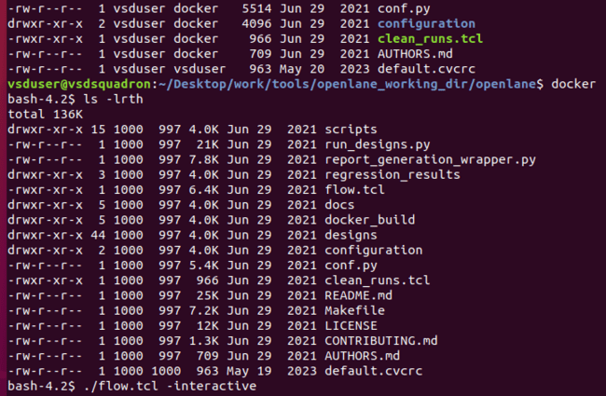

(Image credits:- AUTHOR)

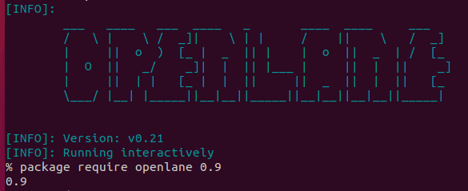

(Image credits:- AUTHOR)

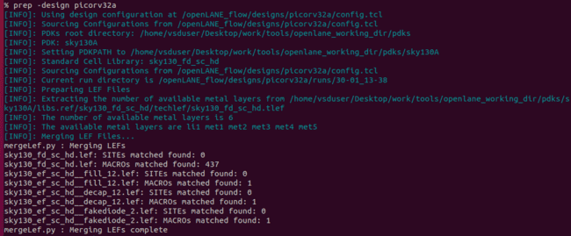

(Image credits:- AUTHOR)

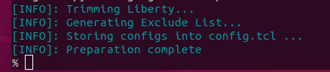

(Image credits:- AUTHOR)

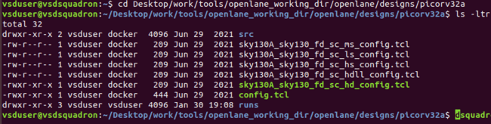

(Image credits:- AUTHOR)

**Good Floorplan vs Bad Floorplan and Introduction to Library Cells**

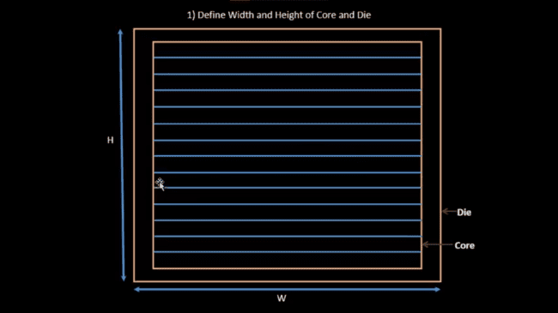

(Image credits:- VSDIAT)

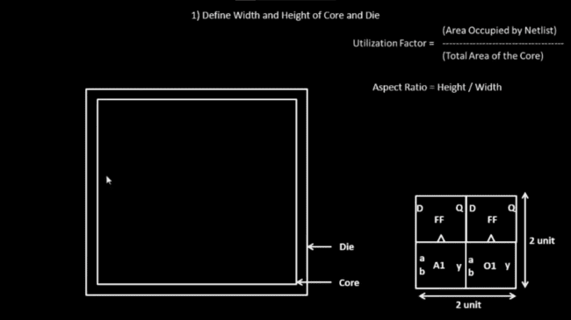

(Image credits:- VSDIAT)

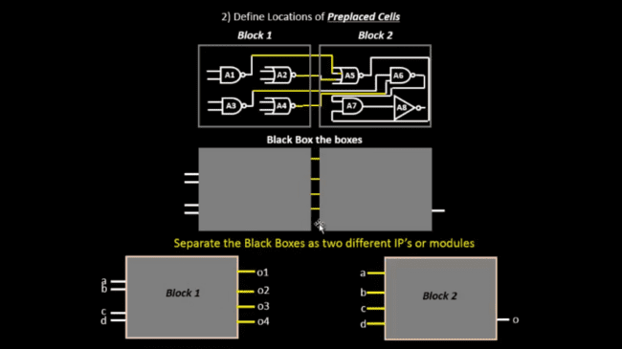

(Image credits:- VSDIAT)

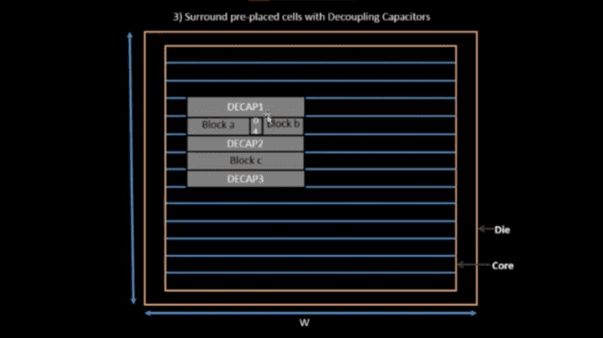

(Image credits:- VSDIAT)

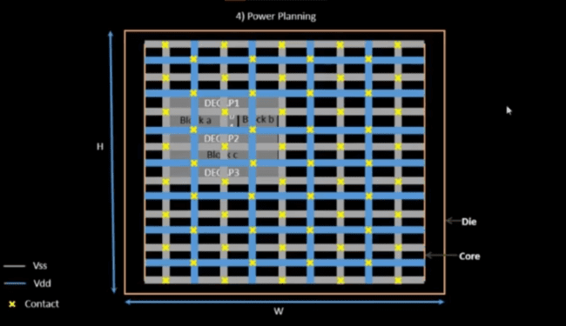

(Image credits:- VSDIAT)

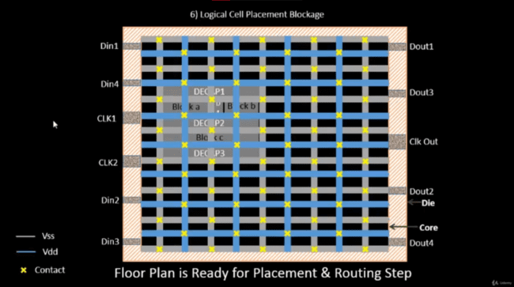

(Image credits:- VSDIAT)

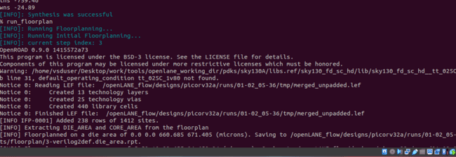

(Image credits:- AUTHOR)

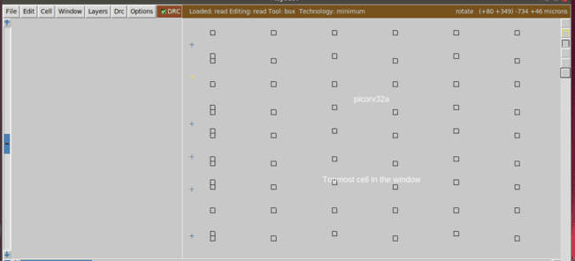

(Image credits:- AUTHOR)

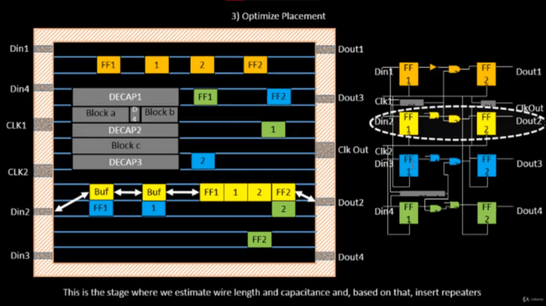

(Image credits:- VSDIAT)

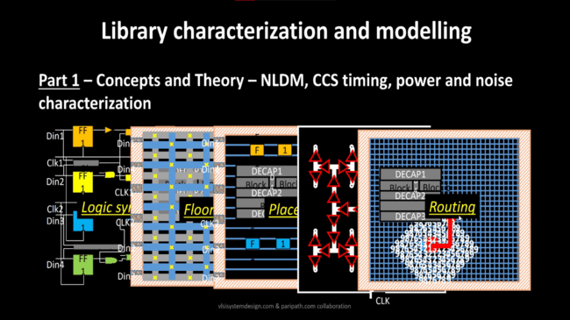

(Image credits:- VSDIAT)

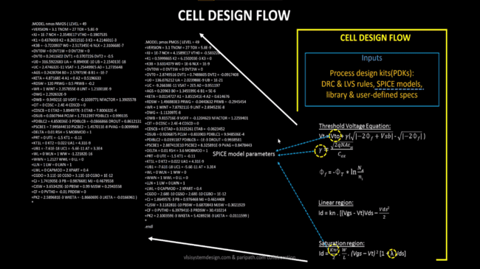

(Image credits:- VSDIAT)

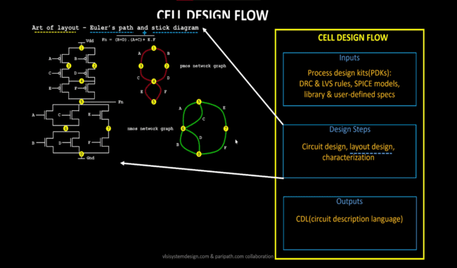

(Image credits:- VSDIAT)

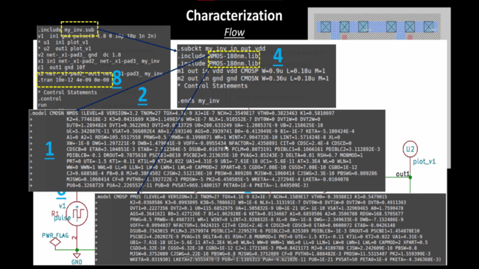

(Image credits:- VSDIAT)

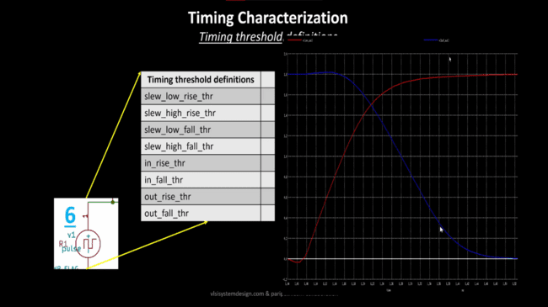

(Image credits:- VSDIAT)

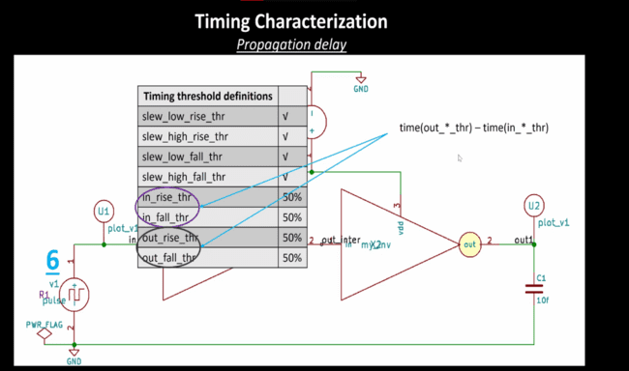

(Image credits:- VSDIAT)

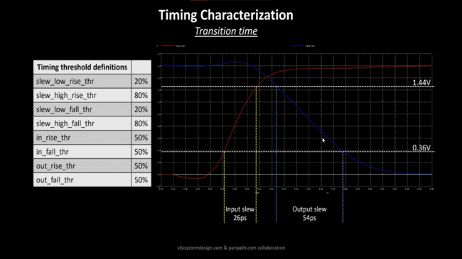

(Image credits:- VSDIAT)

**Design Library Cell using Magic Layout and ngspice characterization**

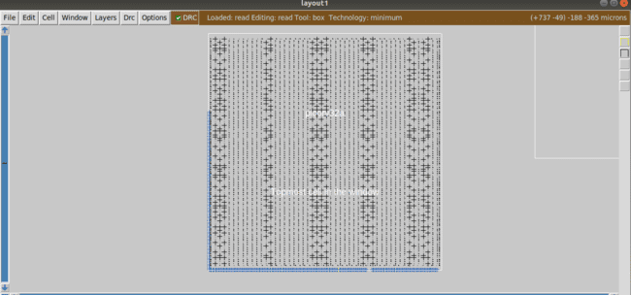

(Image credits:- AUTHOR)

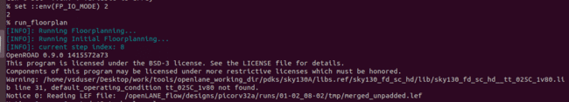

(Image credits:- AUTHOR)

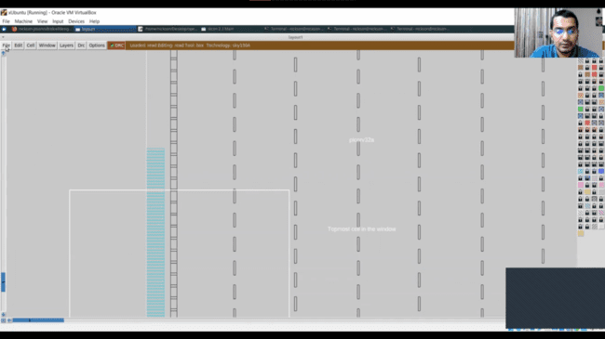

(Image credits:- VSDIAT)

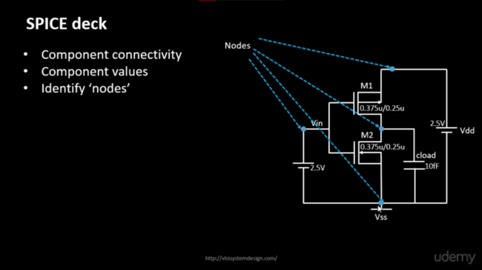

(Image credits:- VSDIAT)

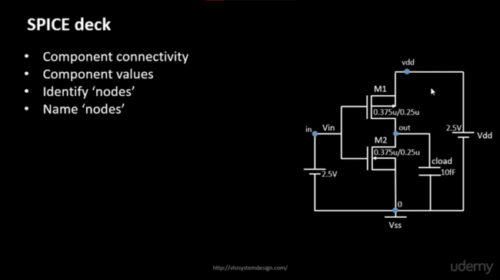

(Image credits:- VSDIAT)

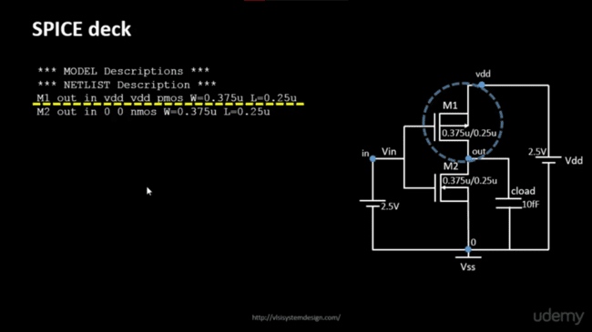

(Image credits:- VSDIAT)

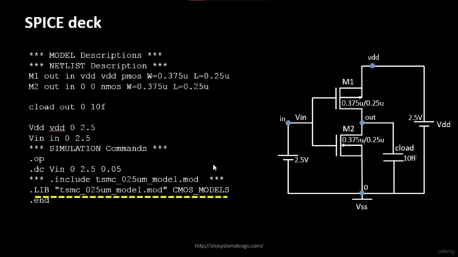

(Image credits:- VSDIAT)

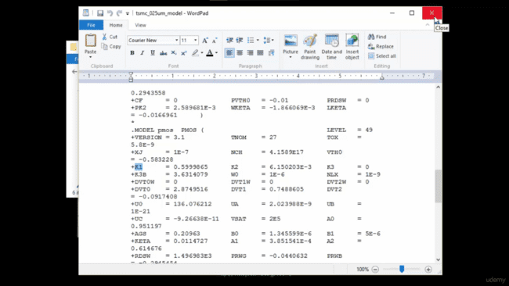

(Image credits:- VSDIAT)

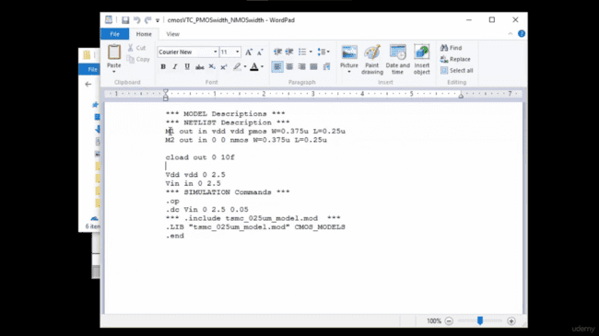

(Image credits:- VSDIAT)

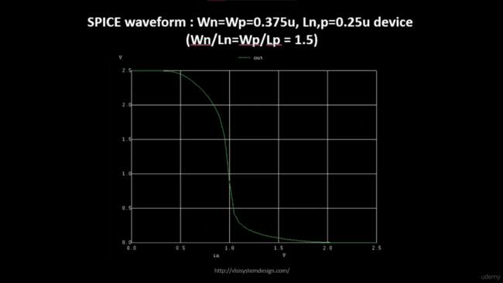

(Image credits:- VSDIAT)

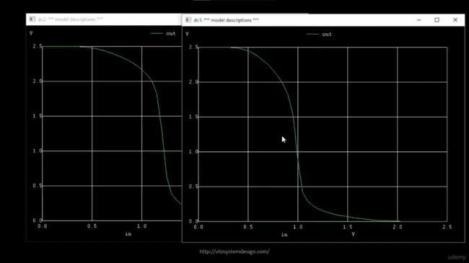

(Image credits:- VSDIAT)

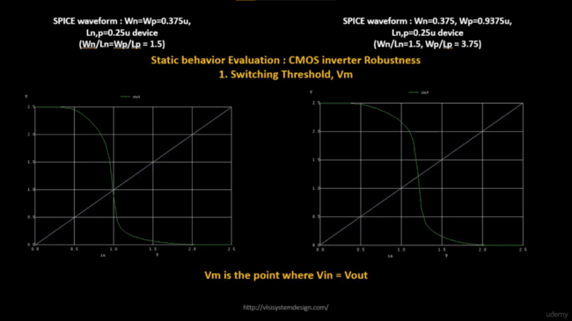

(Image credits:- VSDIAT)

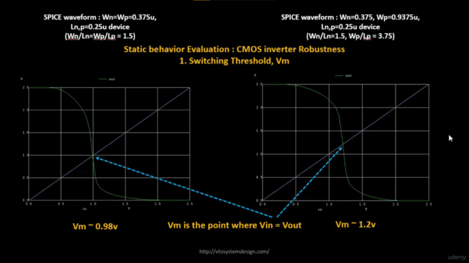

(Image credits:- VSDIAT)

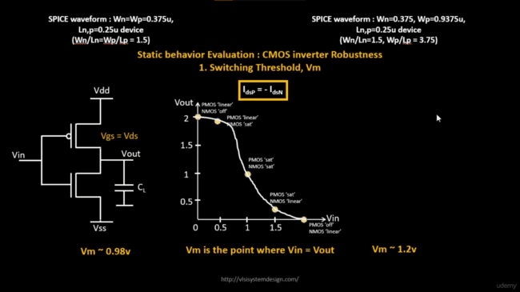

(Image credits:- VSDIAT)

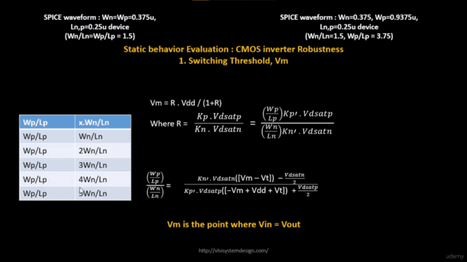

(Image credits:- VSDIAT)

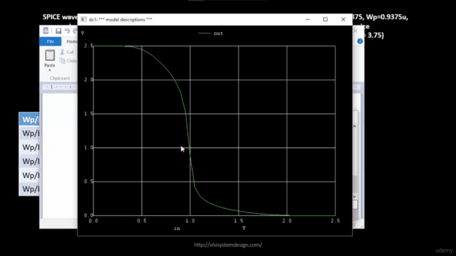

(Image credits:- VSDIAT)

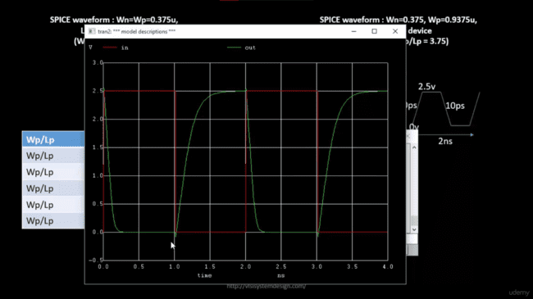

(Image credits:- VSDIAT)

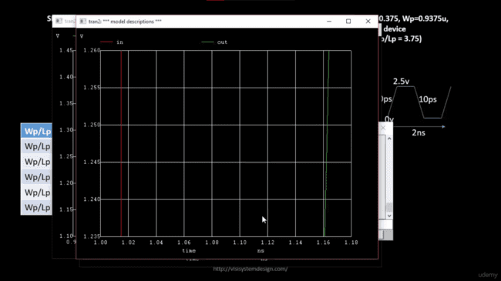

(Image credits:- VSDIAT)

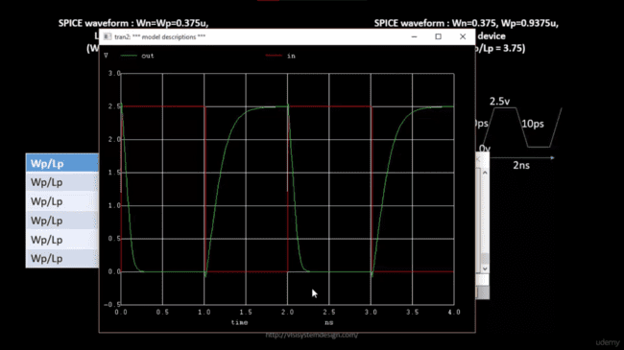

(Image credits:- VSDIAT)

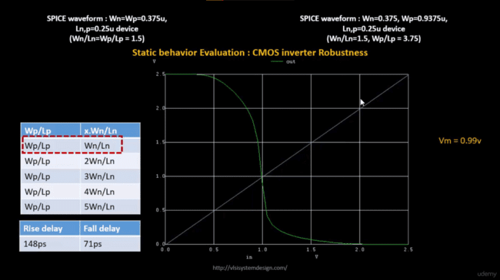

(Image credits:- VSDIAT)

command launching layout 1.png

(Image credits:- AUTHOR)

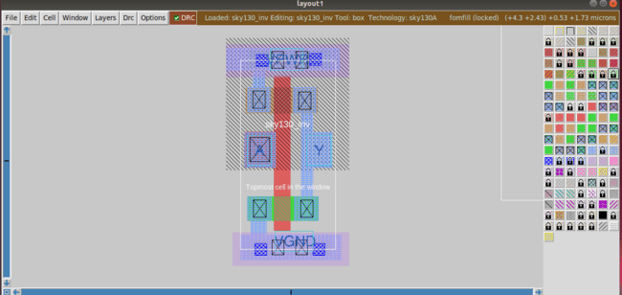

(Image credits:- AUTHOR)

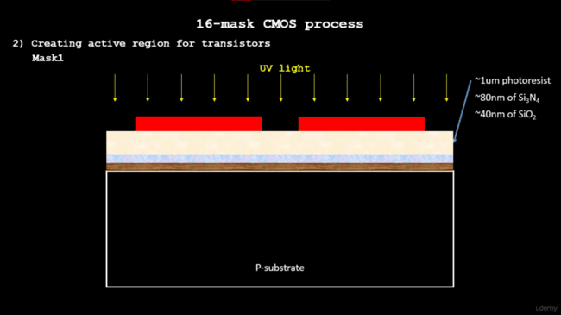

(Image credits:- VSDIAT)

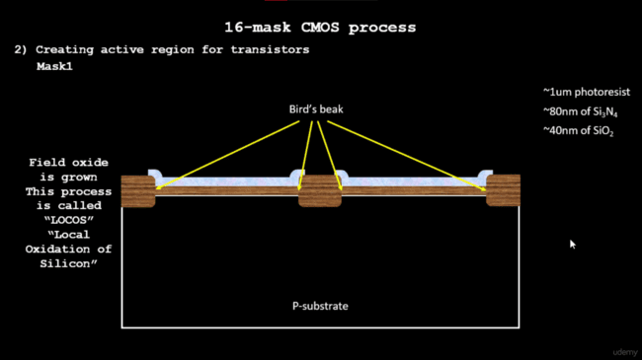

(Image credits:- VSDIAT)

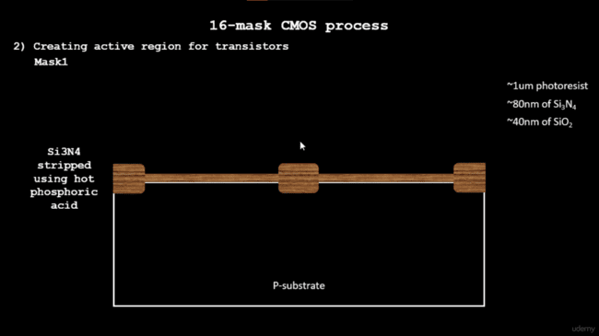

(Image credits:- VSDIAT)

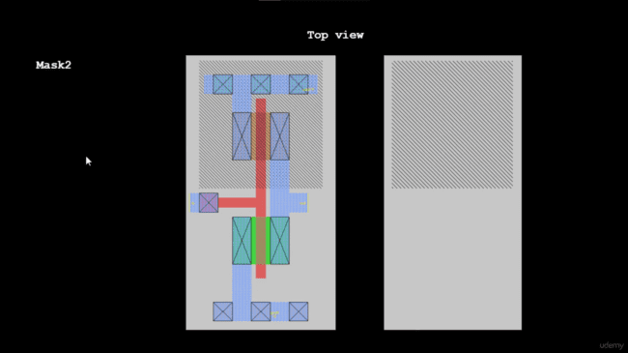

(Image credits:- VSDIAT)

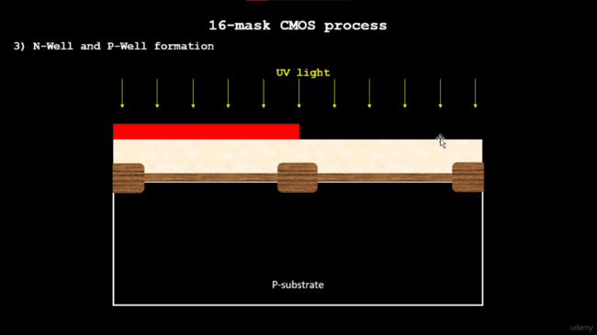

(Image credits:- VSDIAT)

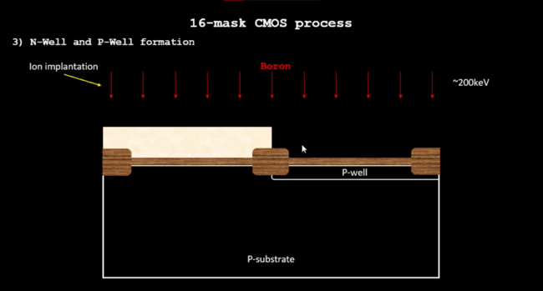

(Image credits:- VSDIAT)

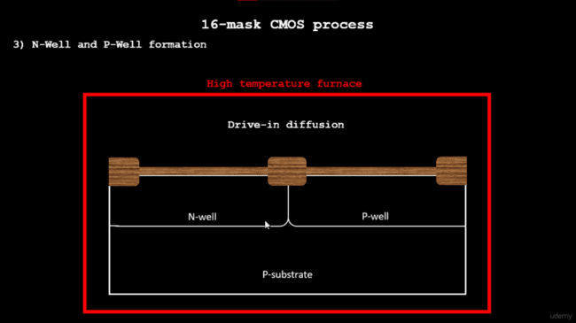

(Image credits:- VSDIAT)

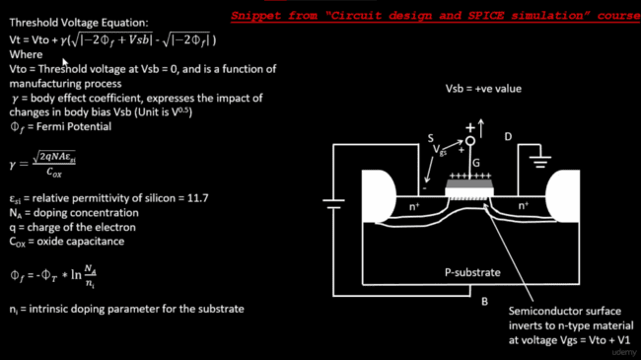

(Image credits:- VSDIAT)

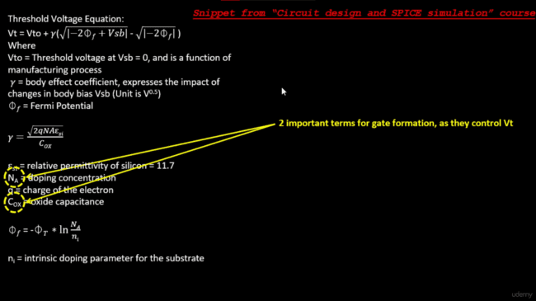

(Image credits:- VSDIAT)

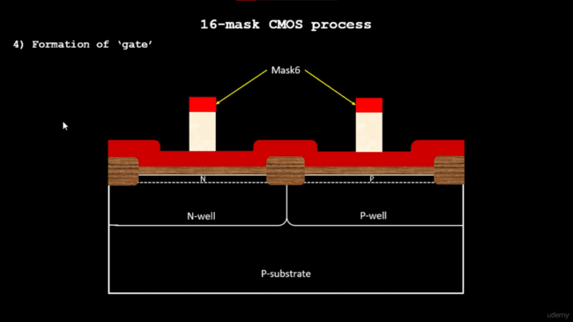

(Image credits:- VSDIAT)

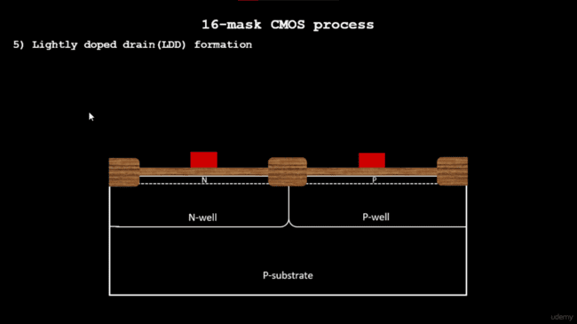

(Image credits:- VSDIAT)



(Image credits:- VSDIAT)



(Image credits:- VSDIAT)



(Image credits:- VSDIAT)



(Image credits:- VSDIAT)

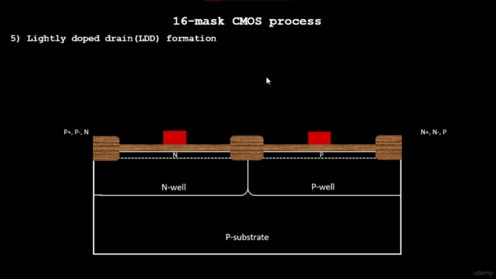

(Image credits:- VSDIAT)

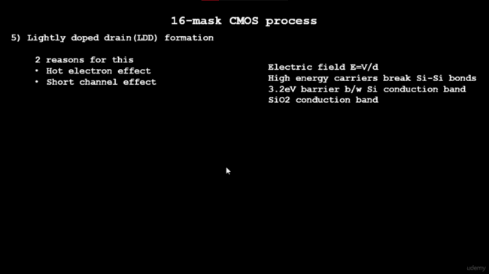

(Image credits:- VSDIAT)

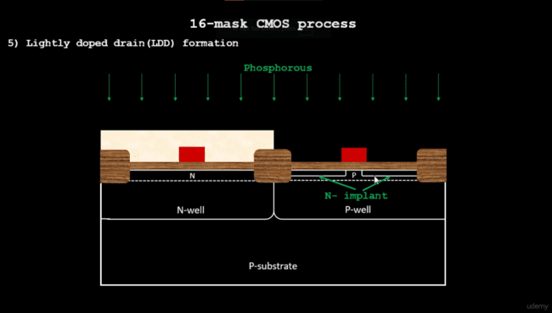

(Image credits:- VSDIAT)

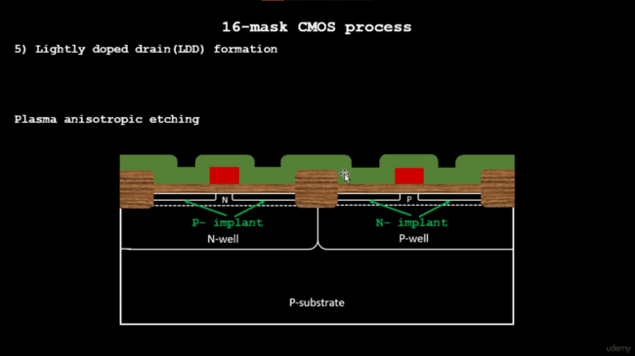

(Image credits:- VSDIAT)

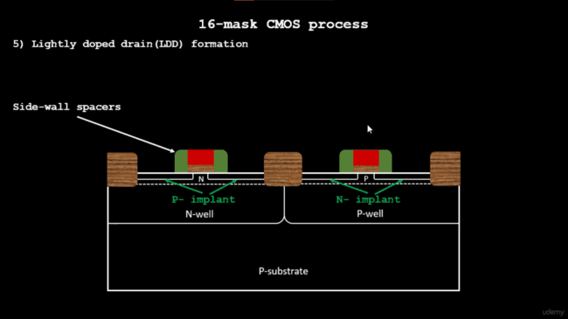

(Image credits:- VSDIAT)

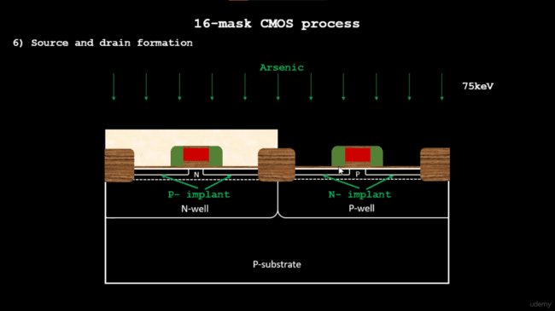

(Image credits:- VSDIAT)

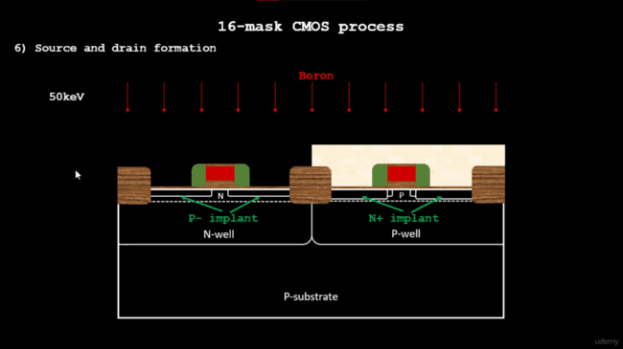

(Image credits:- VSDIAT)

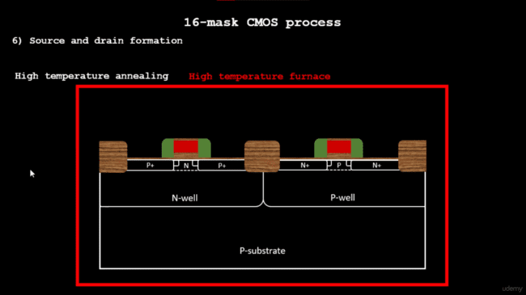

(Image credits:- VSDIAT)

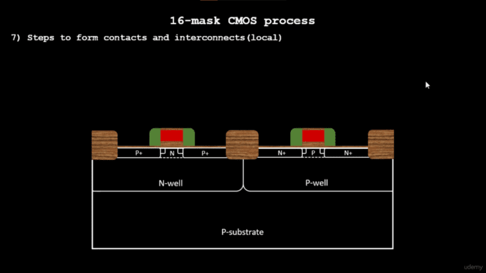

(Image credits:- VSDIAT)

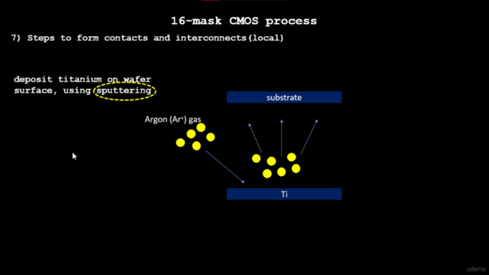

(Image credits:- VSDIAT)

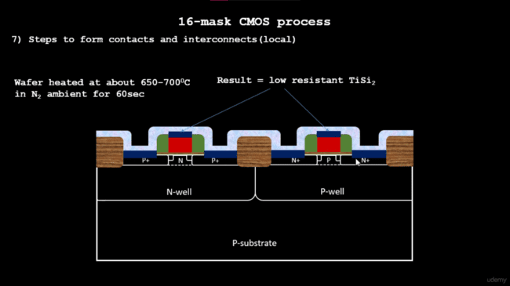

(Image credits:- VSDIAT)

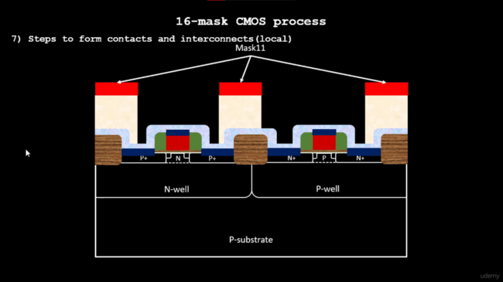

(Image credits:- VSDIAT)

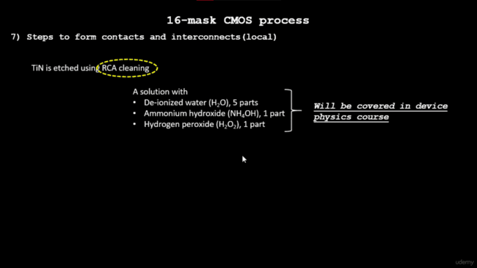

(Image credits:- VSDIAT)

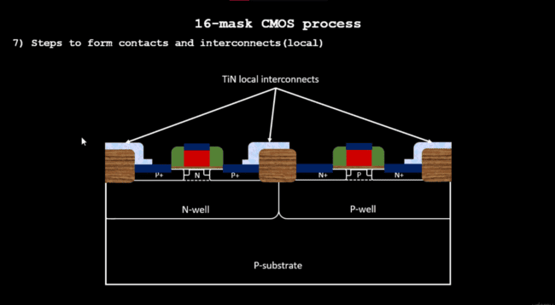

(Image credits:- VSDIAT)

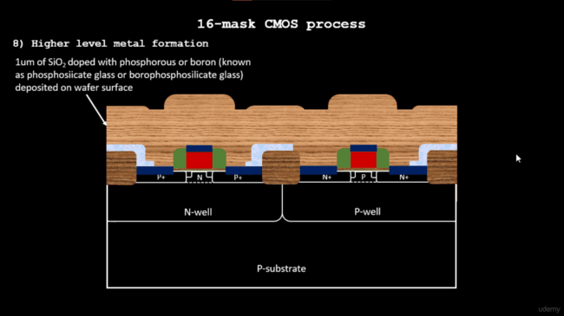

(Image credits:- VSDIAT)

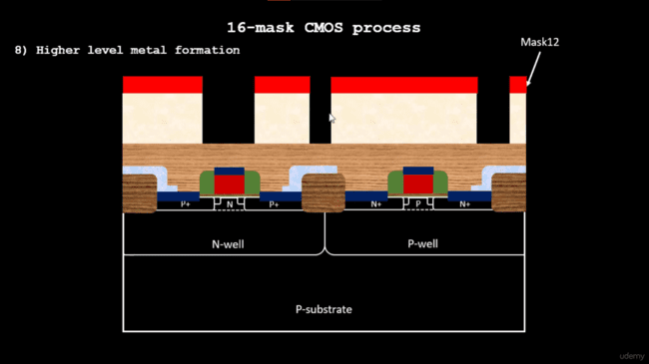

(Image credits:- VSDIAT)

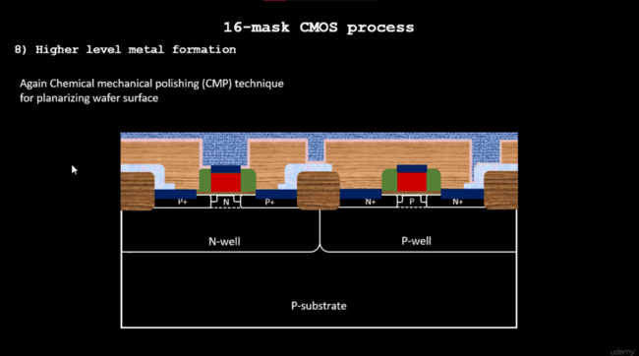

(Image credits:- VSDIAT)

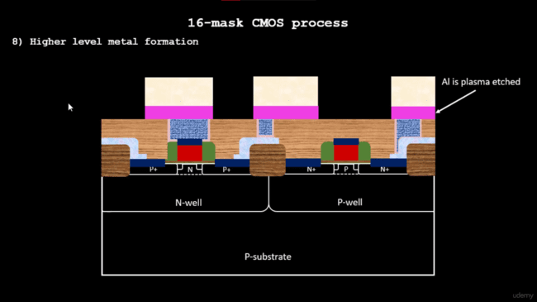

(Image credits:- VSDIAT)

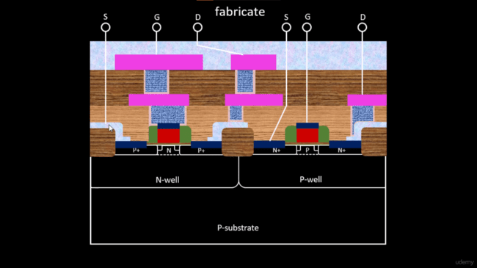

(Image credits:- VSDIAT)

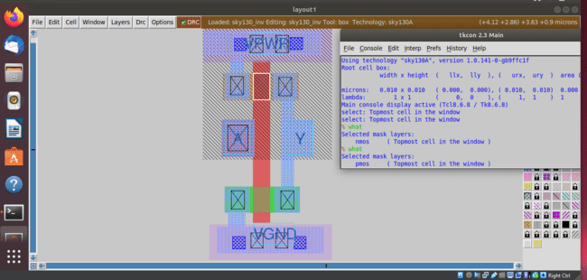

(Image credits:- AUTHOR)

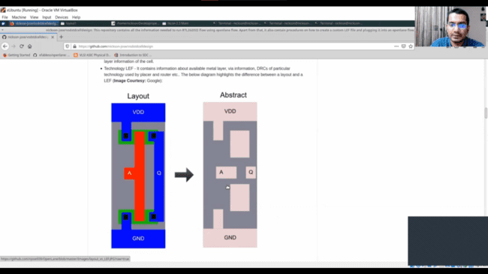

(Image credits:- VSDIAT)

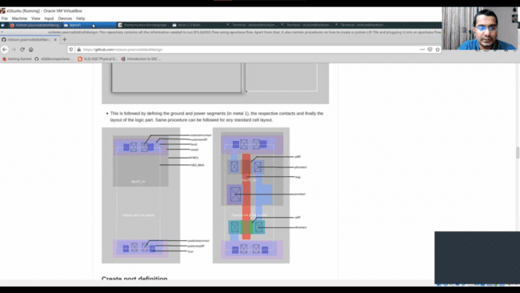

(Image credits:- VSDIAT)

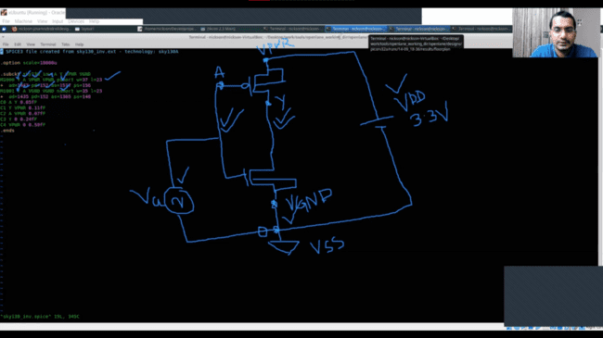

(Image credits:- VSDIAT)

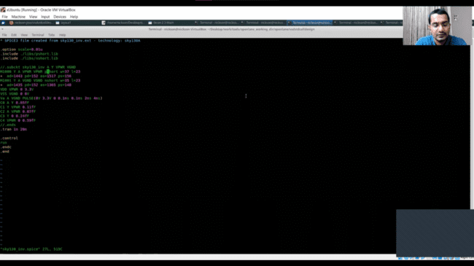

(Image credits:- VSDIAT)

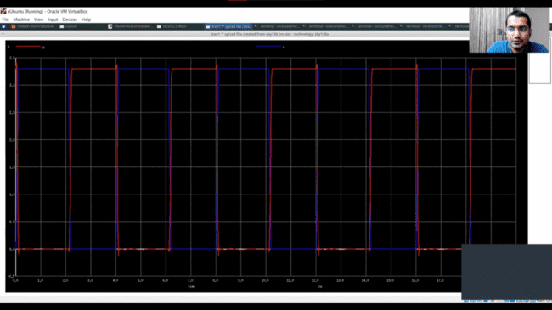

(Image credits:- VSDIAT)

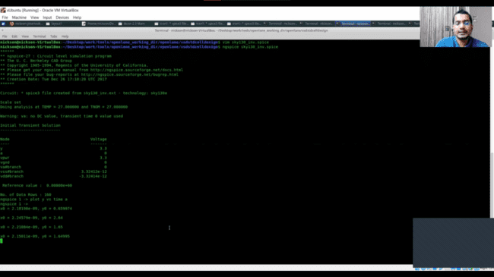

(Image credits:- VSDIAT)

**Pre-layout timing analysis and importance of good clock tree**

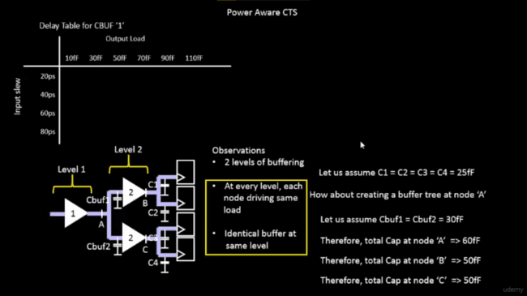

(Image credits:- VSDIAT)



(Image credits:- VSDIAT)

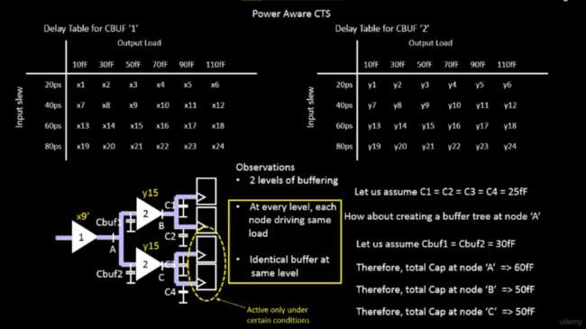

(Image credits:- VSDIAT)

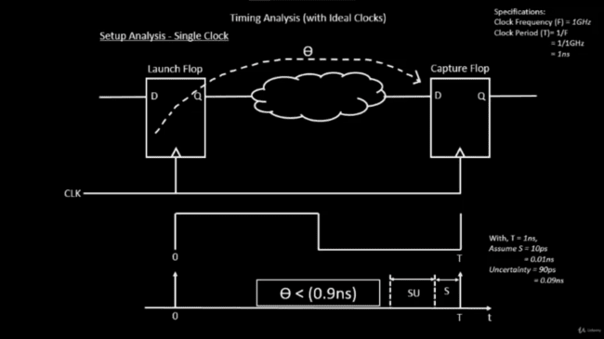

(Image credits:- VSDIAT)

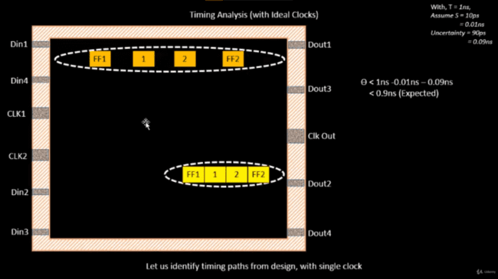

(Image credits:- VSDIAT)

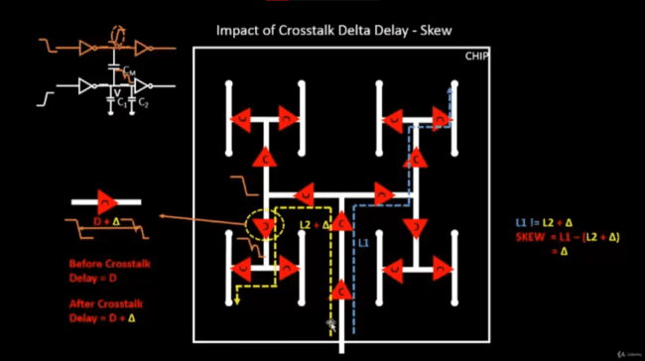

(Image credits:- VSDIAT)

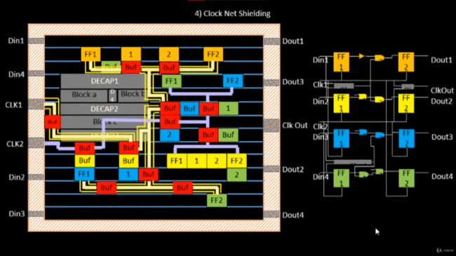

(Image credits:- VSDIAT)

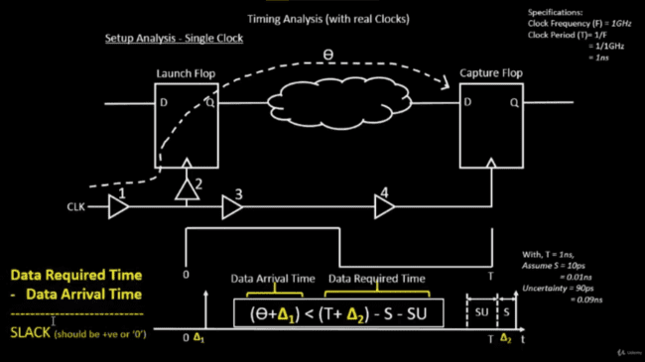

(Image credits:- VSDIAT)

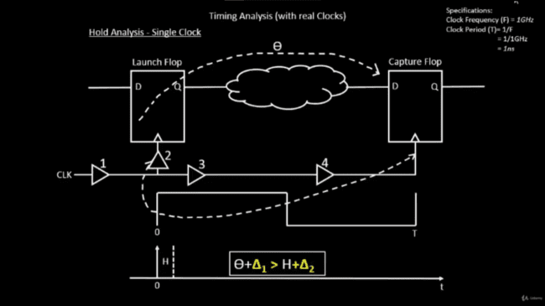

(Image credits:- VSDIAT)

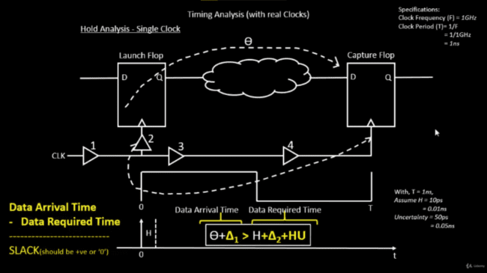

(Image credits:- VSDIAT)

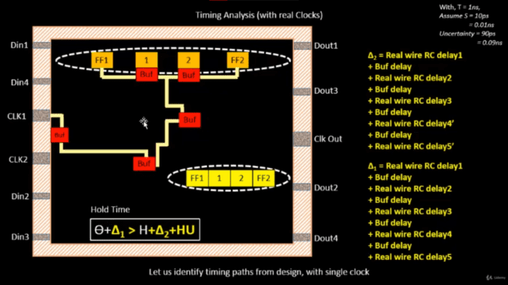

(Image credits:- VSDIAT)

**Final steps for RTL2GDS using tritonRoute and openSTA**

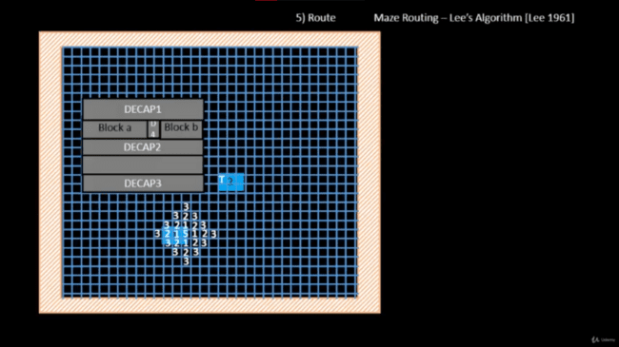

(Image credits:- VSDIAT)

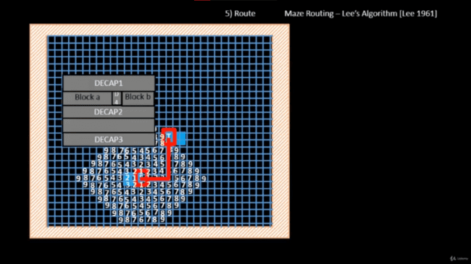

(Image credits:- VSDIAT)

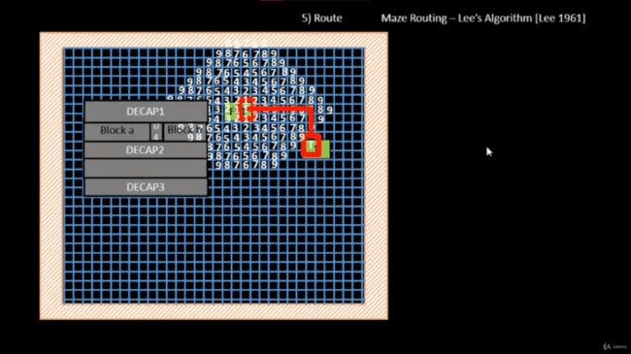

(Image credits:- VSDIAT)

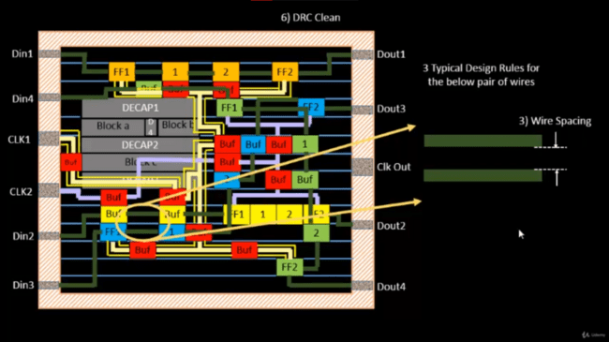

(Image credits:- VSDIAT)

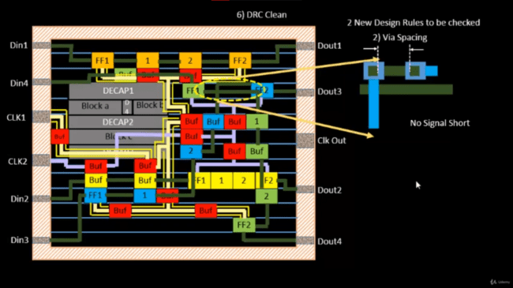

(Image credits:- VSDIAT)

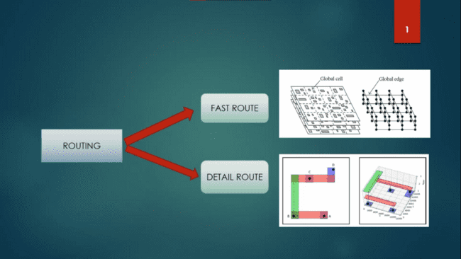

(Image credits:- VSDIAT)

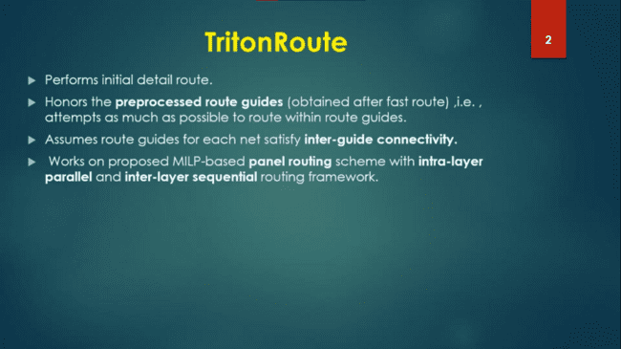

(Image credits:- VSDIAT)

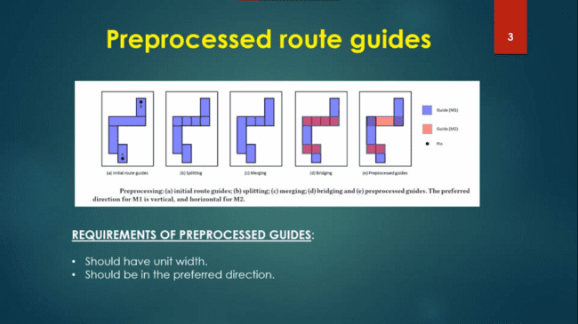

(Image credits:- VSDIAT)

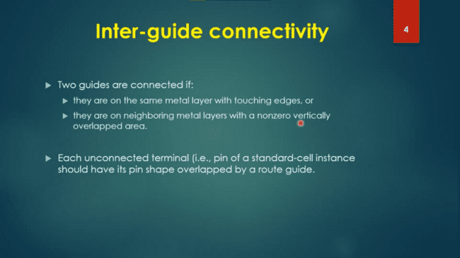

(Image credits:- VSDIAT)

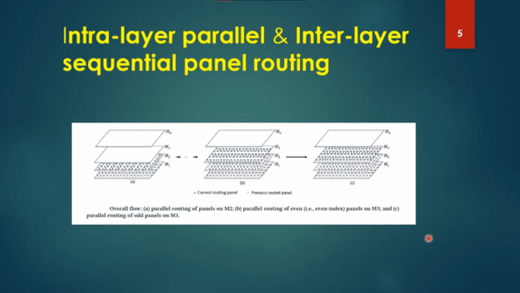

(Image credits:- VSDIAT)

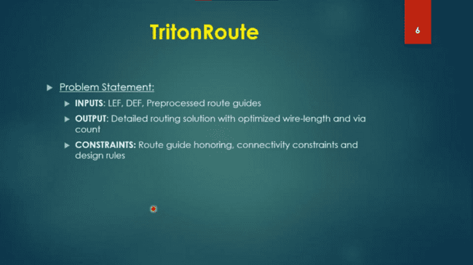

(Image credits:- VSDIAT)

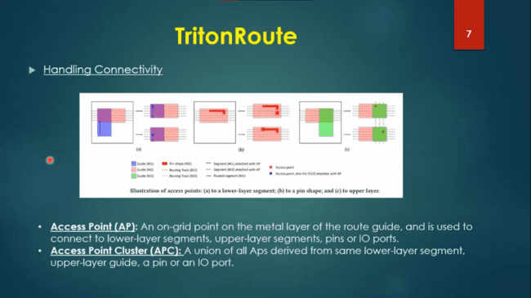

(Image credits:- VSDIAT)

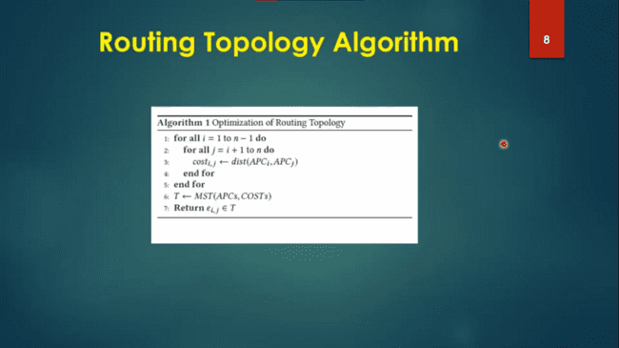

(Image credits:- VSDIAT)